Herra Tohtori’s Starfield Tutorial for Gimp 2
Written by ShadowWolf_IH

Starfield creation can be painful, as I’ve found out. Luckily for me, I found good help along the way. I had a basic idea on how to do it, but HT showed me the way that works best for me, hopefully it will for you too. There will be times in this tutorial that I deviate from what I learned, but these steps will be optional and will be clearly marked, as DEVIATING. If you just want to get the basics down, skip the DEVIATING as you get to them, and go back to them at a later time. These sections are just some things I found along the way, and thought I would impart them to the reader.

OPEN AND FILL A NEW IMAGE

The first thing we need to do is create a new image. Do this by selecting “File/New”.

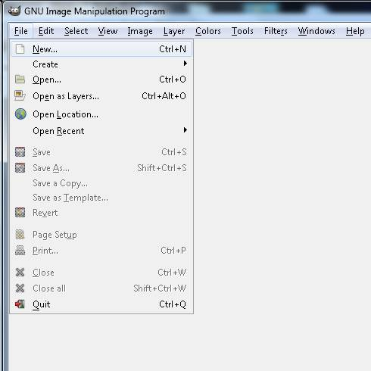

Clicking “File/New” will bring open the dialogue box for creating the new image. Let’s make our new starfield 1024 x 1024.

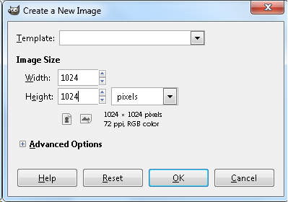

DEVIATING
I prefer to set my ppi at 300, so here’s how. See the + in the square next to “Advanced Options”? Click it. You get an addition in your dialogue box.

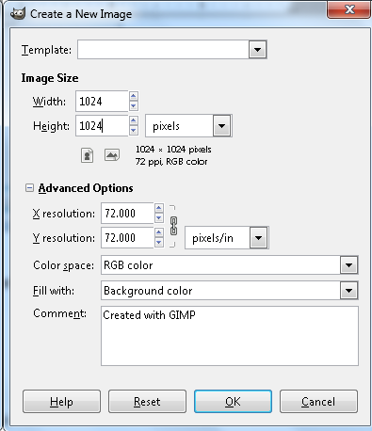
With this new dialogue open, change “X Resolution: 72” to “X Resolution: 300”. Do the same for Y Resolution.

END DEVIATING

Click “OK”.

Now we need to make the background black. The easiest way is to hit “Edit/Fill with FG color”.

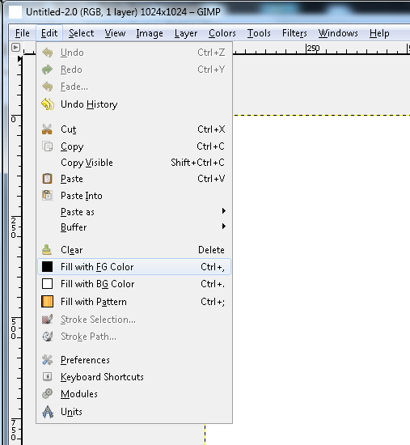

You should now have a black background to your image. If you don’t, then you need to turn off your computer, rebox it, and return it to where you bought it.

Moving on.

STAR CREATION

We are now going to add some stars. We do this by creating visual noise.
Click “Filters/Noise/RGB Noise”.
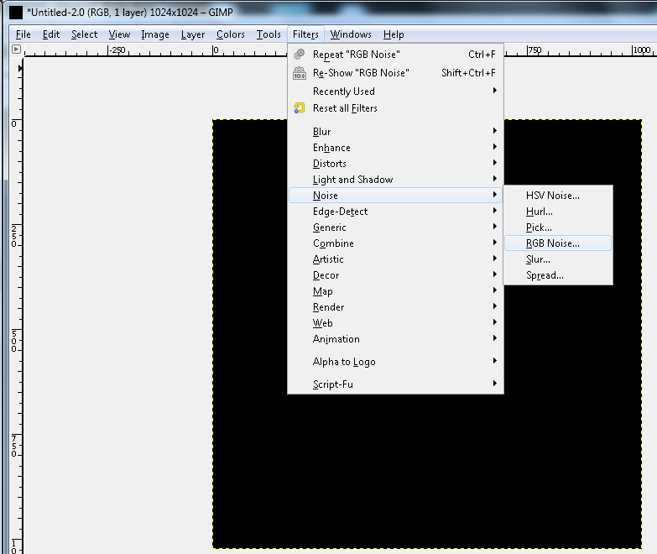

Which brings up the RGB Noise dialogue box. Notice that the only difference between your dialogue box and the one pictured here, is that you have “Independent RGB” checked and I do not. Uncheck it.

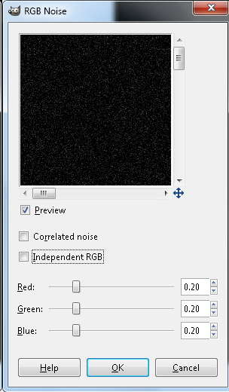

Hit “OK”.

You should now have teeny little white dots on your black field.

At this point i am going to forego images of the menu items. I don’t think we need a picture for: Click “File/New”.

However I will still show images of the dialogue boxes and such.

DEVIATING

You can hit “View/Zoom/1:1 (100%)” to get a good view of what is going on.

END DEVIATING

Now, pick Colors/Brightness/Contrast. Bring the Brightness to 70, and the Contrast to 110. You can move the sliders around to see what kind of effect it has. Basically, if you bring the Contrast up, you see less of the very dim stars, if you bring Brightness up, you brighten the image altogether. Try it out to find good balance.

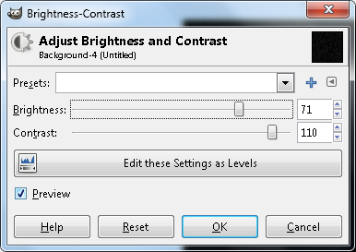

Once you find what you like, hit “OK”.

You should have something like this (if you have zoomed in to 1:1 (100%).

The next thing that you need to do is to duplicate the layer. Stars farther away are smaller and dimmer, so let’s make this happen. Duplicate the layer by hitting “Layers/Duplicate”, I am going to do what I do not usually do. I am going to name this layer, for the sake of the tutorial.

DEVIATING

In your toolbox window you can view the layers. It looks like this:

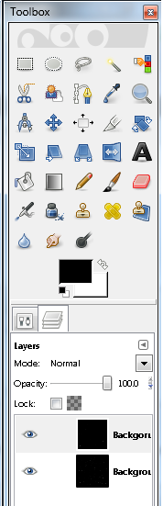

The two layers are both named Background, the one on top is the duplicate, so we want to change the name on that one. Easy as pie. Simply double click on the Background in the top layer. I am changing the name to Layer2, and will refer to it as Layer2 from here on in. You may want to do the same.

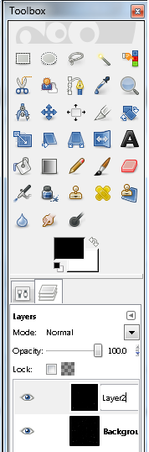

This will make things more clear as move on.

END DEVIATING

CREATING SOME DEPTH

You now have an exact duplicate of the original layer. So once again bring up your Brightness/Contrast by hitting “Colors/Brightness-Contrast”. This time set Brightness to -90, and Contrast to 90.

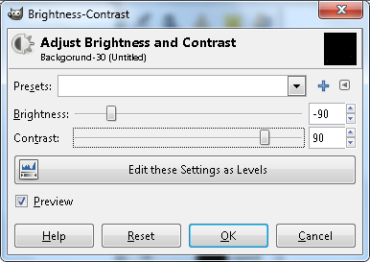

The only stars visible in this layer now, are the stars that were the brightest to begin with. These stars, being the brightest, are the ones that we are going to give a bit of color to. Hit “OK”.

If you are zoomed in, as before, you should see something like this:

The next thing that we need to do is to add a slight corona. No, not a beer best served with lime, but a halo. We do this by blurring these bright stars a little. Hit “Filters/Blur/Gaussian Blur”, and the Gaussian Blur dialogue will open. Set both Horizontal and Verticle to 1, and make sure RLE is on. RLE is the default, but a glance makes sure. When you do this the stars will dim a bit, don’t worry, it’s normal.
Hit “OK”.

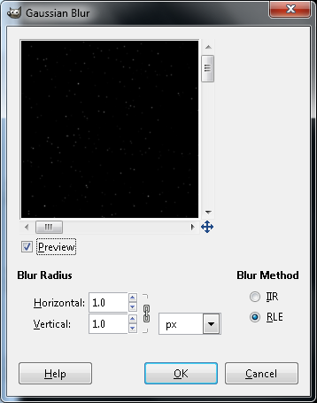

Once this is done, click “Colors/Auto/Stretch Contrast”. There is no dialogue box to show, it will simply render it. Now the stars are bright again.

COLORING THE BRIGHTEST STARS

The next thing that we need to do is to create a new layer for color. Note create, not duplicate. Click “Layer/New Layer”. This brings up the new layer dialogue box. Change the layer name to “Colors”, and make sure that “Background Color” is selected.

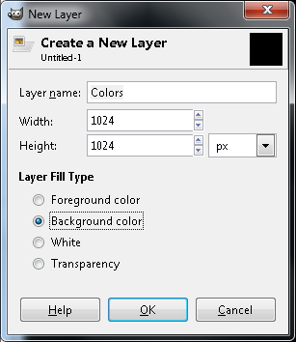

You should now be seeing a white field. Time to add some color. Select “Filters/Render/Clouds/Plasma” to bring up the Plasma dialogue box. Set “Turbulence” to 4, and keep hitting “New Seed” until you get something that doesn’t have a whole lot of Green or Purple in it. There are no Green or Purple stars. So try to find one that doesn’t too much of those colors.

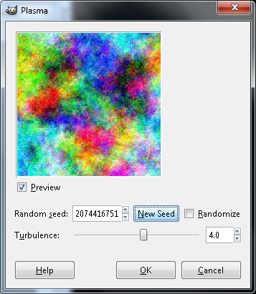

It is important to note that HT actually me taught me two ways to color the stars, but in his words “might give better results but requires a few more operations” he states that this may be the better way. For this reason, I am not including the other way in this tutorial. The superior results are well worth the extra operations which are neither numerous nor complex.

Select “Layer/Transparency/Color to Alpha” to bring up the Color to Alpha Dialogue box.

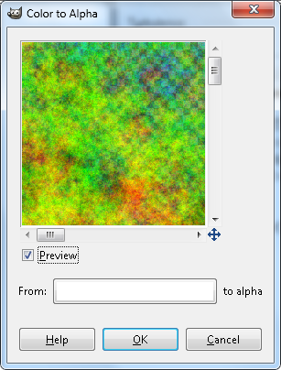

Notice that the button next to “From:” is currently white in color. Click it. This brings up the Color to Alpha Color Picker dialogue box. For HTML Notation, type in “ff00ff” and look at the slider labelled as G. This is the green slider. Reducing it to 0 at this setting gets rid of Megenta. Hit “OK”. The Dialogue box disappears.

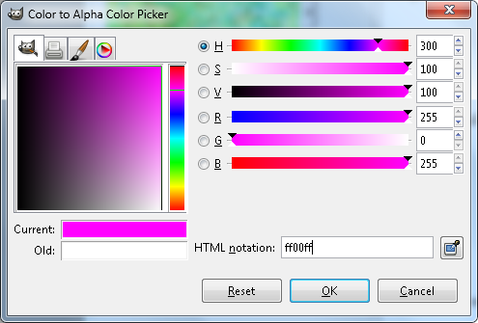
We are now back to the Color to Alpha Dialogue box, but the button is now Magenta. Hit “OK”.

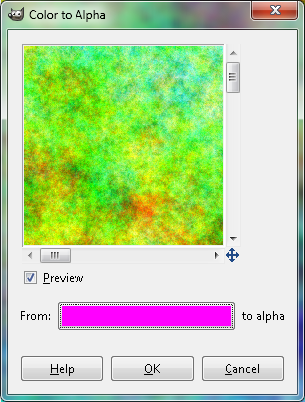

We have gotten rid of Magenta, now to get rid of Green. Same operation. Select “Layers/Transparency/Color to Alpha”. Again click the “From:” button. Now type “00ff00” into the HTML Notation. This will get rid Green.
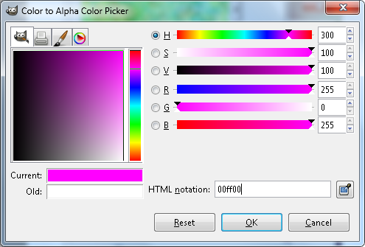

Hit “OK” and we are back at the Color to Alpha Dialogue box again. Hit “OK” in this dialogue box as well.

Now you should have a nebulous colour area that has Red, Blue, Yellow, Cyan and White patches but no Green or Magenta. It should look something akin to this:

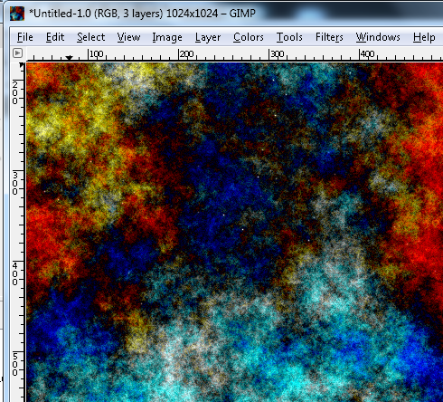

Don’t quit on me now, we are almost there.

In your toolbox window, you can choose which Blend mode you want to use. Blend mode simply dictates how you want the current layer to mix with the others. If you look under the word “Layers”, you see the word “Mode”. Next to mode is a window which says “Normal”, and next to it is a button with a down arrow. Click this button, and then use the scroll bar to scroll to the bottom of the list, and choose “Color”.

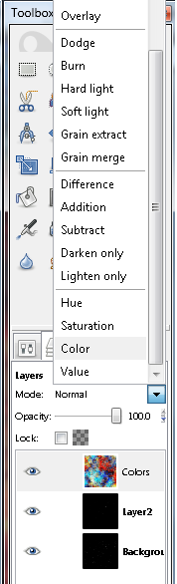

You should now have your brightest stars colored.

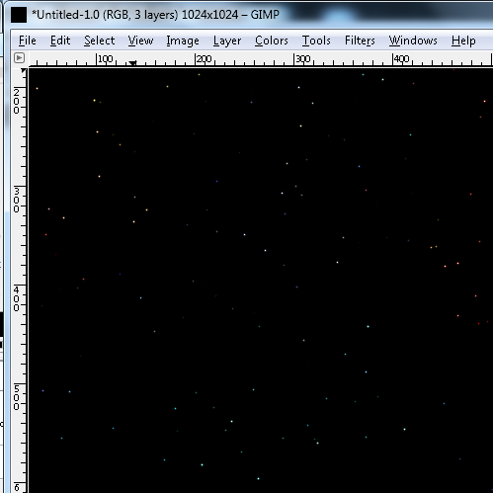

What you are actually seeing is Layer 2. But the White in Layer 2 (stars) is being viewed through the Color layer. Think of that layer as a lens.

HT didn’t teach me this, but I find it easiest. So here we go.

If you click on Layer 2, and change its Blend mode to screen, all of the stars are colored, correct? Correct, and this will not do. So to defeat this, set Layer 2 mode back to Normal. Then simply drag Backround layer to the top of the Layer list. Change the Blend mode to Screen.

What HT did teach me, is to first click the little eye next to the original starfield layer, the one named background. If you cannot see the eye, and the small dim stars are gone, then you are doing this right. Then select “Edit/Copy Visible”, then select “Edit/Paste as Layer”. This takes a picture of the layer with the stars colored. Then creates a new layer out of that image. Then turn the eye back on so you can see the baackground stars, and turn the eye off for everything else except for the brand new layer, which by default is called “clipboard”. Then only the brightest are colored. With this done, click one of the layers that is turned off, and then select “Layer/Delete Layer”. Then do the same for the other layer that is no longer needed. If you want the stars to be brighter and show more color, simply paste as layer again. Repeat this til you are happy.

Show off the results.

