**Herra Tohtori’s Nebula Tutorial for Gimp 2**

*Written by ShadowWolf_IH*

A few notes before we begin the tutorial proper.

Save often, but always save as .xcf until the final.

We are going to do this in 2048 x 2048. The nebulae created in this tutorial can stand alone, or be lashed together. In 2048^2 mode, we will be lashing them together. To make them as standalone, you will need a larger size, 4096 works, 8192 is taxing on memory. The steps taken are the same. For your first run through I ask that you use 2048^2, as we will be using coordinates for lashing purposes.

Remember that due to differences in monitor setting, your images may not appear exactly as mine, but they should be close enough for our purposes.

This tutorial will assume a familiarity with Gimp2. If you are unfamiliar with Gimp 2, the tutorial on starfield creation will familiarize you enough with Gimp2 to follow this tutorial. Since you are going to need a 2048x2048 starfield anyway, you’d may as well get HT’s Starfield Tutorial. You can get it at one of the following links, whichever format works for you.

<http://casofwar.hard-light.net/images/HTstarfieldtut.wps>  
  
<http://casofwar.hard-light.net/images/HTstarfieldtut.doc>  
  
<http://casofwar.hard-light.net/images/HTstarfieldtut.docx>

Ok go ahead and open your starfield. Or create one, if you create one, the very last step will be to select “Image/Flatten Image”. This will merge all of the layers into one.

Now that we have our starfield, let us begin our journey into the wonderful world of Nebula creation.

**Head in the clouds**

Create a new Layer by selecting “Layer/New Layer”, Foreground (if it is black, if background is black, use it instead) color selected, and name it “Neb1”. See *fig 1-1*. Then hit “OK”.

***fig 1-1***

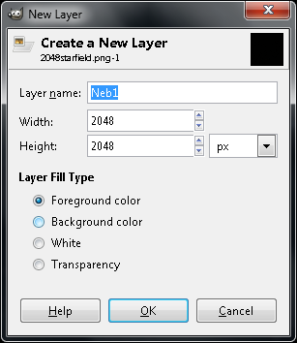

The next thing we are going to do is render some clouds. Select “Render/Clouds/Solid Noise” with detail set to 15, x and y both set to 8, check “Tilable”, and for Random seed enter 1473944742. The random seed entry is only for this tutorial. When you do this a second time, find a random seed that pleases you. Note, if you get a bunch of diagonal motion blur or easily distinguishable repeating patterns, as in *fig 1-2*, you will want to choose another random seed. A good one is the one we are going to be using. See fig *1-3*. Then hit “OK”.

***fig 1-2***

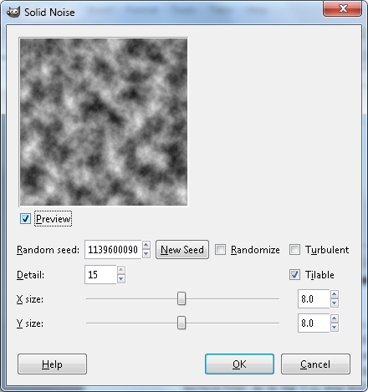

***fig 1-3***

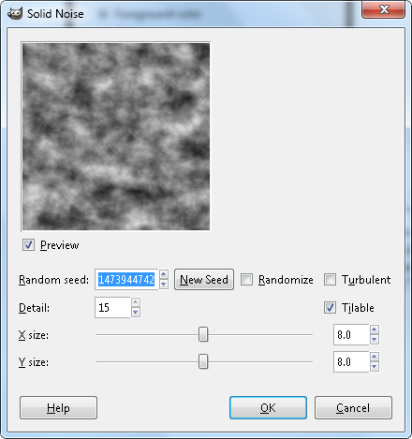

The next step is to Select “Colors/Levels”. Make sure you are dealing with input levels and set “Black”to 138, and “White” to 231. Hit “OK”. What we want to do is make isolated nebula clouds here. When you do another one, you may have to mess with black to get them isolated. It’s easy. See fig *1-4*. Hit “OK”.

***fig 1-4***

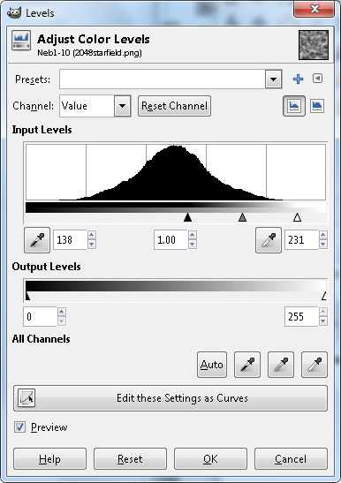

Next we will make a new layer by selecting “Layers/New Layer”. Name this new layer Neb2. See fig *1-5*. Then hit “OK”.

***fig 1-5***

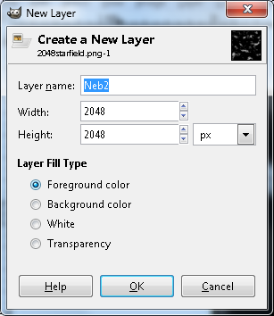

We will now render solid noise again, making it the exact same as layer Neb1, except we will also select “Turbulent”. The nice thing is, when we select “Render/Clouds/Solid Noise”, it brings up the exact same options that were last used. Make the selection, be sure to select “Turbulent”. See *fig 1-6* and hit “OK”.

***fig 1-6***

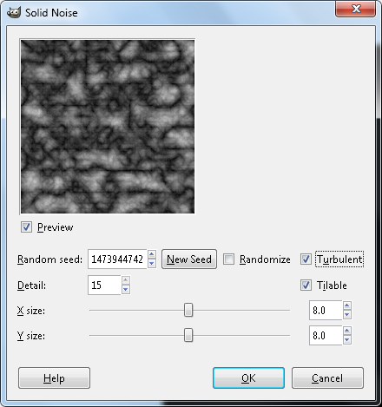

Next we will play with the levels again. Select “Colors/Levels”, and set “Black”to 110, and “White” to 246. Once again, be sure that these are the input levels, not the output levels. See *fig 1-7*, and hit “OK”.

***fig 1-7***

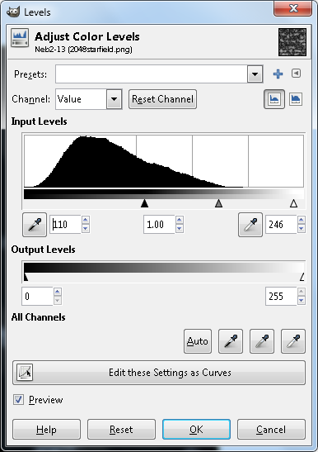

Now set the blendmode of Neb2 to screen. Drag Neb1 to the top of the list, and set its blendmode to overlay. See *fig 1-8*.

***fig 1-8***

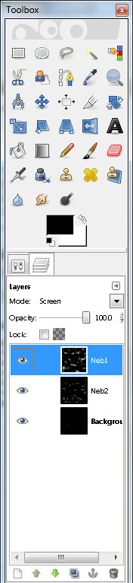

At this stage of the game, the image should be a good deal less cluttered. *Fig 1-9* shows the upper left portion of the image viewed at 50% zoom.

***fig 1-9***

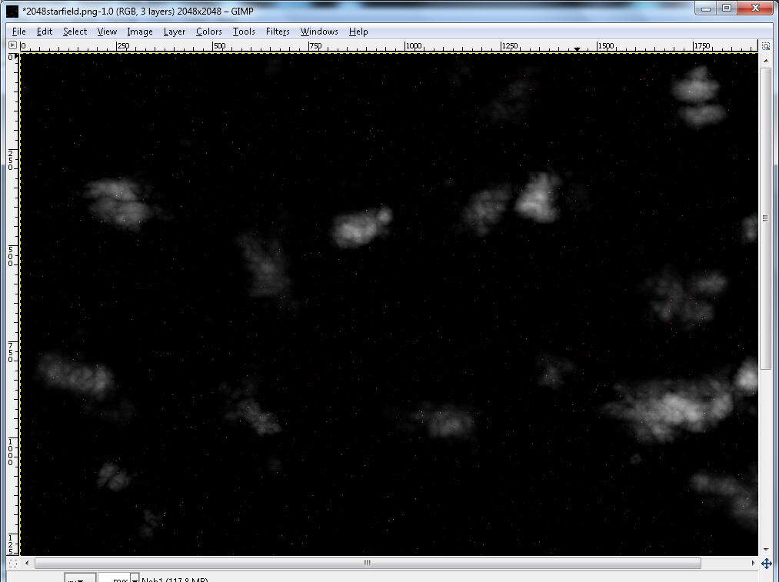

With this done, move the background layer (your starfield) to the top of the list, and set its blendmode to “screen”. Then create a new Black layer called “Black”, by selecting “Layers/New Layer” and move it to the bottom of the list. Your layer order should look like *fig 1-10*.

***fig 1-10***

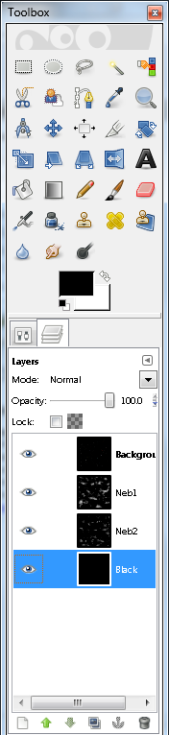

Disable the starfield by hitting the little eye that corresponds to that layer. With that finished, select “Copy Visible”. Now select “Edit/Paste as/New Layer”, and then rename the layer to “Neb-Base”. The final step of this section is to move Neb-Base in the order until it is just below the starfield layer. See *fig 1-11*. Note that I have enabled the starfield and disabled Neb1 and Neb2.

***fig 1-11***

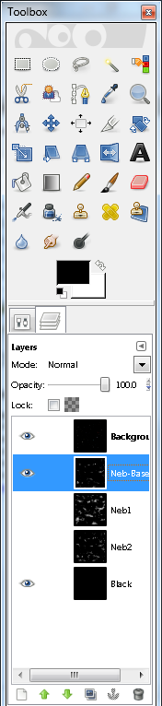

Right now your top left quadrant should look like *fig 1-12*.

***fig 1-12***

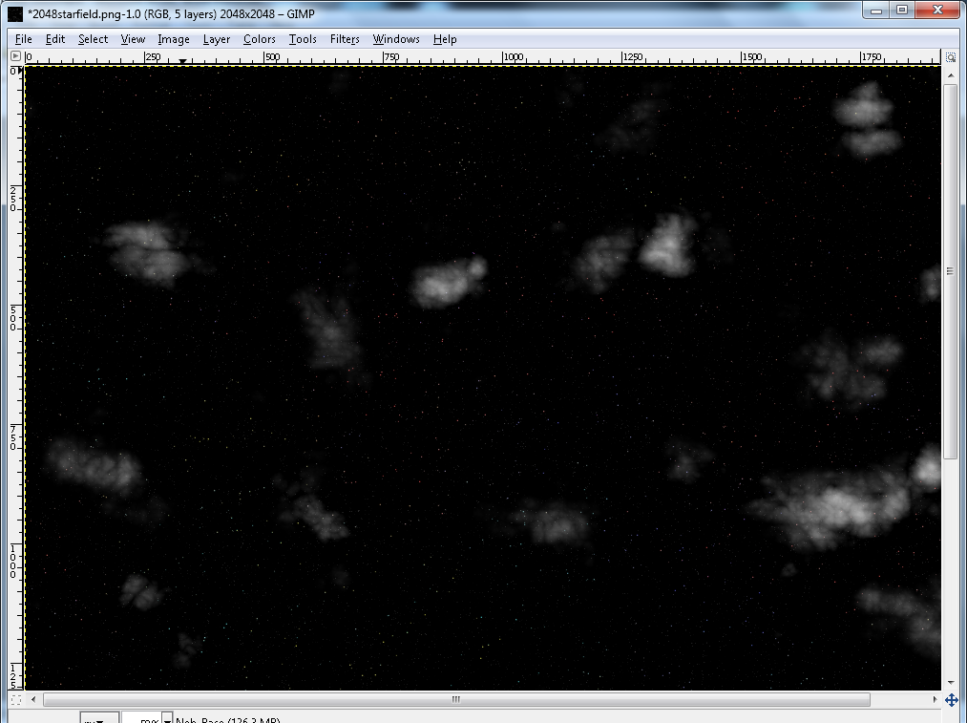

**Colorize my life**

Sick of Black and White, me too. Let’s add some color to this puppy.

Start by creating (you guessed it) a new layer. Select “Layers/New Layer” and name it Neb-Base-Color. Then select “Filter/Render/Clouds/Plasma”. Set Turbulence to 1, and use random seed 3346220722. See *fig 2-1* and hit “OK”.

***fig 2-1***

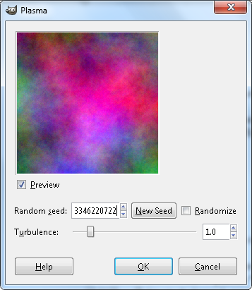

Drag this layer until it is between the starfield, and Neb-Base. Then set its blendmode to color. Your layer order should look like mine. See *fig 2-2*.

***fig 2-2***

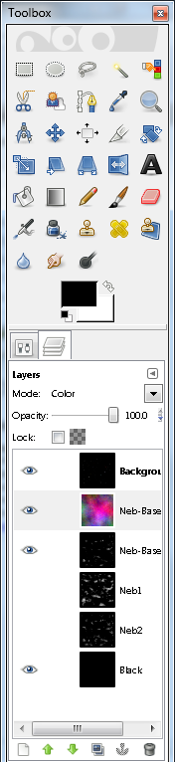

You should now have some very vivid coloring to your clouds. If after this step you don’t like what you have, you can always undo to the point where you rendered the plasma, and then try again with a different random seed. But for now, leave it alone. I chose this seed because in this exercise we will be using the lasso to lash items together. For stand alone nebulae, you would want to choose a random seed that isn’t mostly one color.

Enable both Neb1 and Neb2, and set the blend mode of Neb-Base to screen. You should see quite a difference. See *fig 2-3* to check your work.

***fig 2-3***

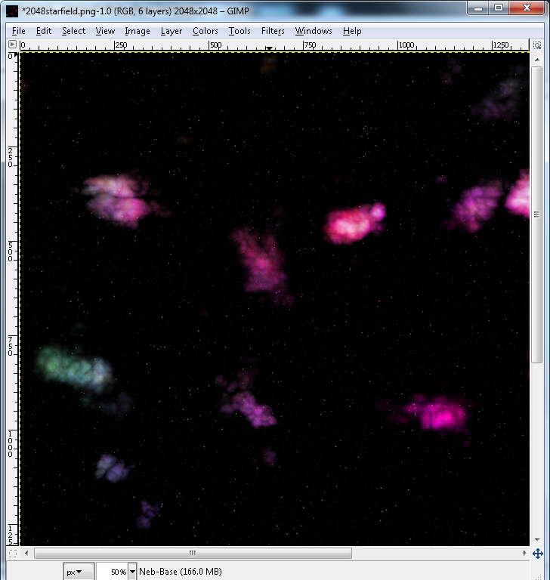

If the clouds aren’t big enough, when you do this again, try using less x/y detail when making Neb1 and Neb2. For what I am wanting to show you, these are about perfect.

Now let’s play with Opacity a bit. Once again, the figures used here are only for the use of this tutorial. It will be up to you to find something you like. For this, set the Opacity of both Neb-Base, and Neb-Base-Color to 40%. Do this by selecting the layer you want to work with (click the layer), Then adjusting the Opacity slider. See *fig 2-4* if you are unsure how to do this.

***fig 2-4***

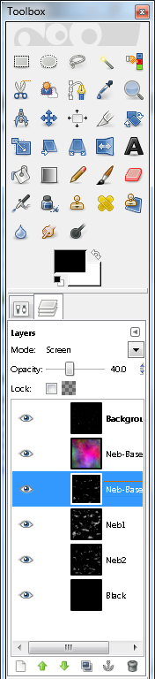

By adjusting the Opacity of Neb-Base, we are in effect adjusting the brightness of the nebulae, and by adjusting the Opacity of Neb-Base-Color, we are adjusting the saturation, or, how intense the color is.

That’s about it for coloring the nebulae. Simple stuff.

**Whispful thinking**

A little bit of whispy goes a long way. We are going to add the slight whisps that you see in the nebulae. So the first thing we need is a new layer. Click on Neb-Base-Color, so that it is the layer selected, then select “Layer/New Layer”. Name the new layer Neb3. Doing it this way will add the new layer above Neb-Base-Color, but below the starfield, and that is where we want it.

With Neb3 selected, select “Filter/Render/Clouds/Solid Noise” with “Random Seed” is 940010622, “X” and “Y” should both be at 16, “Turbulent” selected, “Tilable” selected, and “Detail” to 15.

Next select “Colors/Invert”. You should now be seeing a black field with white sqiggly lines all over it. Extreme lightning is a good term. We need to tone it down.

Select “Colors/Levels”, and again in input, set “Black” to 64, and “Gamma” to .15, now it should be a little less extreme. See fig 2-5, then hit “OK”.

***fig 2-5***

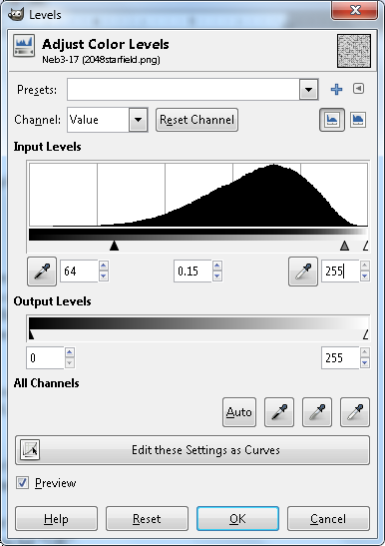

Like all settings for Levels, these are entirely up to the artist to decide what looks best. Personally i would stay in 59-69 range for Black, and .1 to .2 range for Gamma on this step. Even then 59 with .2 is a touch much, but you’ll see what I mean when you experiment with it.

Now still with Neb3 selected, select “Layers/Add Layer Mask”. You will get a dialogue box. Just go with the default settings and hit “OK”. In the layer tree, Neb3 doesn’t appear to be any different, but next to the small image of the layer there is actually a white box. Clicking there will outline it in blue. Click it now to see what I am talking about.

Select Neb1, and copy it. I always use CTRL+C for this step. When you paste something into a layer mask, it isn’t anchored, so you have to do this yourself. Click on that white box in Neb3 (the layer Mask), and paste it using CTRL+V, then anchor it using CTRL+H. If you did all of this correctly, you should have an image that looks like *fig 2-6*.

***fig 2-6***

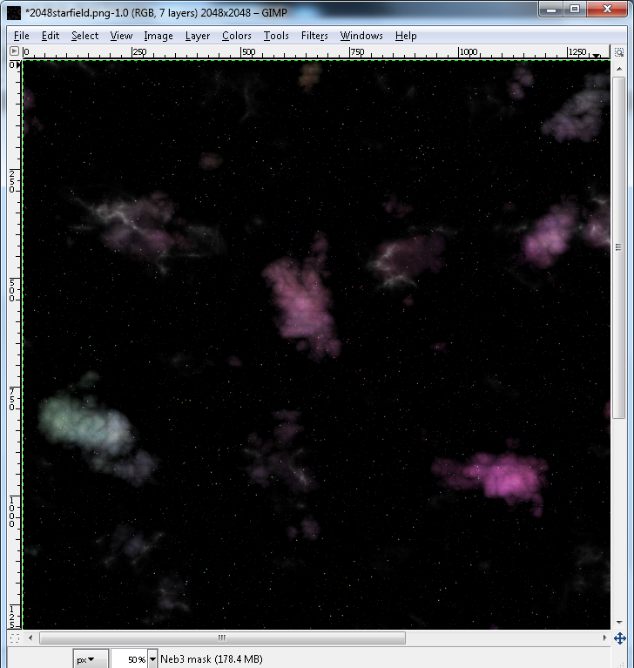

Now we need to disable a few layers. Namely, Neb-Base, Neb-Base-Color, and the starfield layer which should at this point be on top of everything else.

Now select Neb3, and add a layer above it by selecting “Layers/New Layer”. Name this layer Neb-Top-Color.

With Neb-Top-Color selected, select “Render/Cloud/Plasma”, with “Turbulence” set to 1, and “Random Seed” 1569290948. See fig 2-7, and hit “OK”.

***fig 2-7***

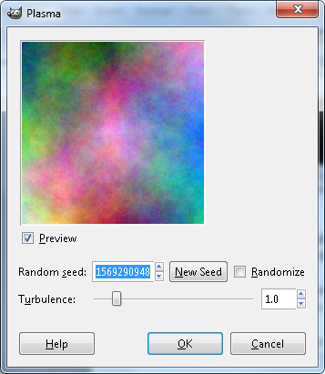

Once it has rendered, set the Blendmode to “Color”, and the Opacity to 30%.

Select “Edit/Copy Visible”, then select “Edit/Paste as/New Layer”. Name the new layer Neb-Top.

Now we need to disable Neb-Top-Color, and Neb3. We need to enable Neb-Base, Neb-Base-Color, and starfield. Set Neb-Top blendmode to Screen, with 50% Opacity. You should already have some fairly convincing nebulae formations. But we aren’t done. Remember, doing this is higher resolutions will produce larger nebulae with more detail in them. In 2048^2 they are quite small, but we will be using them later. Right now you should have a duplicate of *fig 2-8*.

***fig 2-8***

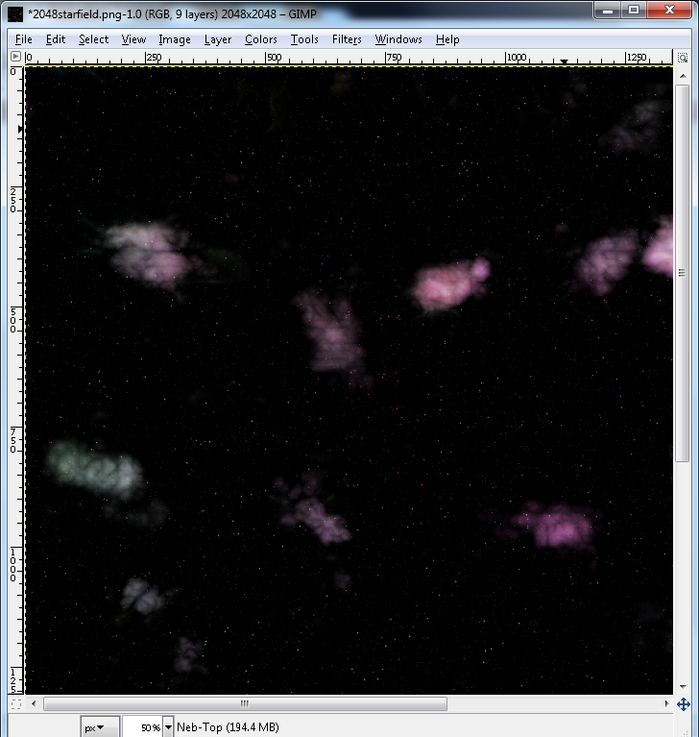

Finally, drag Neb-Top up so that it is above Neb-Top-Color, and below the starfield. Then enable everything except for Neb-Top-Color, which needs to be disabled. See *fig 2-9* for the layer order and enabling. It may help to widen the toolbox, or the Layers/Channels/Path/Undo window, whichever you are using to manage your layers

***fig 2-9***

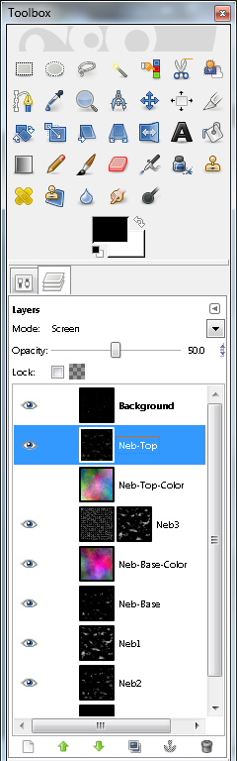

**What’s my line?**

We next need to discuss striations. This little dark lines caused by who knows what. This is an art tutorial, not a science tutorial. Anyway, there are very faint whisp lines, almost as if being blown by a gentle breeze. This is what we will now emulate.

If you guessed that the first step in this stage would be creating a new layer you guessed right. Select Neb-Base, then select “Layers/New Layer” and name the new layer Striation. Then render some plasma by selecting “Filters/Render/Clouds/Plasma”. Set “Turbulence” to 1, and “Random Seed” to 2545379861. See *fig 3-1* and hit “OK”.

***fig 3-1***

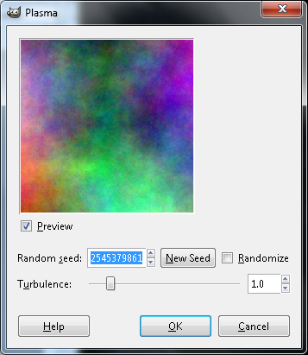

Once it renders, we need to desaturate it. Select “Colors/Desaturate”. When the dialogue box comes up, make sure that “Lightness” is the option selected. See *fig 3-2*, and hit “OK”.

***fig 3-2***

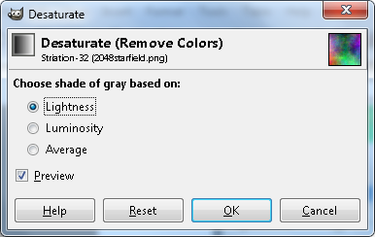

Time to add the striations. Select “Filters/Distort/IWarp”. When the dialogue box comes up, drag it to be a little bigger, set “Deform Amount” to 0.2, and “Deform Radius” to 100. Select “Swirl CCW” or “Swirl CW”. You will have to switch between them during this process, either way click where you want to swirl and drag your mouse a little. It doesn’t take much. When you do this again, if you want denser striations, use a smaller brush. You should end up with something that looks like this. See *fig 3-3* and hit “OK”.

***fig 3-3***

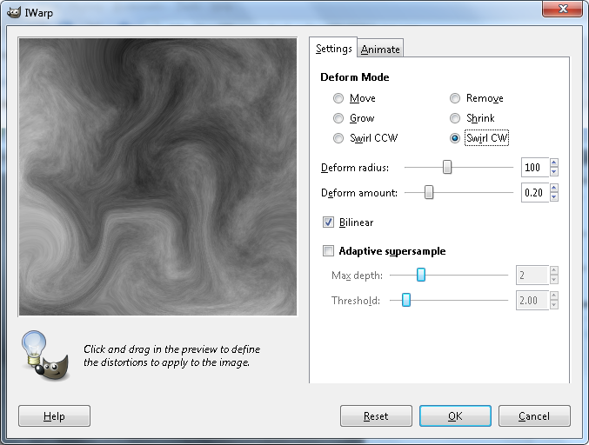

Next we need to stretch the contrast. Do this by selecting “Color/Auto/Stretch Contrast. Then we are going to select “Layer/Transparency/Color to Alpha”. This bring up the Color to Alpha Dialogue box. If the button next to “From:” is white, skip the next step, but if it is not white, we need to change it. Hit the long button next to “From:”, and it brings up the Color to Alpha Color Picker. In this window, for “HTML Notation” just type ffffff. See *fig 3-4* and hit ok.

***fig 3-4***

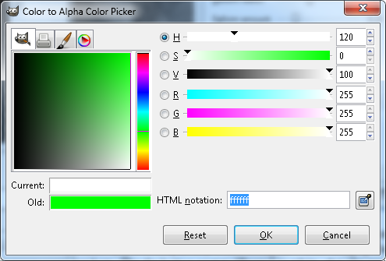

With that accomplished, the button next to “From:” in the Color to Alpha dialogue box should be white. See *fig 3-5* and hit “OK”.

***fig 3-5***

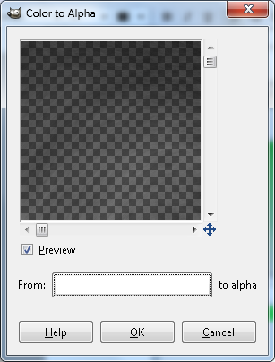

Right now we have a few options for our blend mode. We can go with Overlay or Value, and set the Opacity to something pleasing. Or we can go with Multiply at 85%, and Neb-Base at 75%.

We are going to go with Mutiply at 85%, and Neb-Base at 75%. No matter what you do after this tutorial. Make it pleasing to you.

Striations are not necessary. They do create a subtle difference, and in art, lots of subtle things add up to one big effect.

**VH1 Where are they now? Child stars**

These nebulae are star nurseries, so it is time to add some cute little baby stars.

Don’t make a new layer yet, what are you thinking? Make sure that all the layers are visible except for the starfield, and Neb-Top-Color. Then select “Edit/Copy Visible”, and then select “Edit/Paste as/New Layer”. Move this all the way to the top of the list and name it Luminosity.

Select “Colors/Desaturate”, and check the option for “Luminosity”. See *fig 4-1* and hit “OK”.

***fig 4-1***

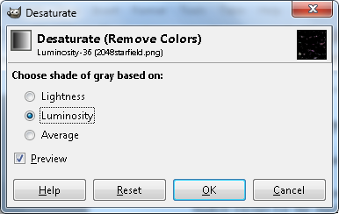

Just to make sure, Luminosity should be on top., then the starfield. If this is the case, select the starfield, and create a new layer by selecting “Layers/New Layer”. Name this layer Brightstars. If Brightstars is above Luminosity, drag it to just beneath Luminosity.

With Brightstars selected, select “Filters/Noise/RGB”. In the dialogue box that appears, be sure to make sure that “Independent” is unchecked. See *fig 4-2* and hit “OK”.

***fig 4-2***

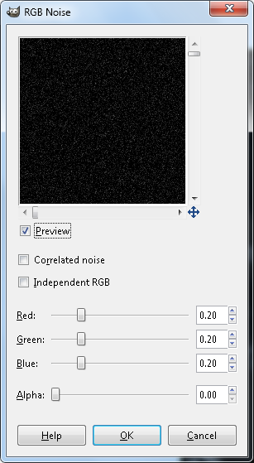

Select the Luminosity layer, and set the blendmode to “Multiply”. You should now see very very faint little stars in place of the nebulae.

Select “Colors/Levels” and apply the following settings to input: Black = 16, Gamma = .75, White =128. See *fig 4-3* and hit “OK”.

***fig 4-3***

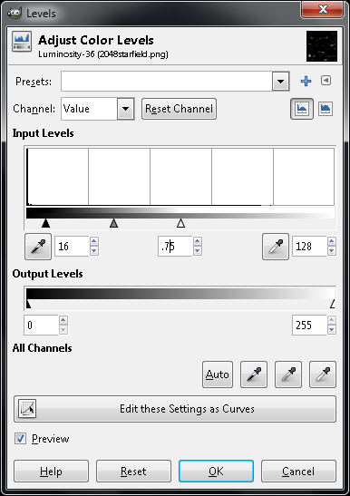

This is where we decide how many stars we want in the nebulae. Select Brightstars again. Select “View/Zoom/100%”, and then use the scroll bars to move to the top right corner of the image. Then Zoom in again to 200%. You should have a good view of the faint stars in this area. Then select “Colors/Brightness and Contrast”. Set Brightness to 60, and Contrast to 110. Adjusting brightness will control the number of stars in the nebulae. Higher brightness is more stars. Only the most minute adjustments are needed here. Basically take brightness to 70, and contrast to 110. Work your brightness from there til you have a desired result. But for this tutorial, set it to 60. Because we are going to be lashing these nebulae together, we don’t want many stars in them. For standalone nebulae, you would want more stars. See *fig 4-4* and hit “OK”.

***fig 4-4***

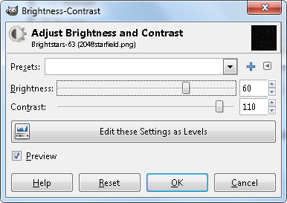

Once again select the Luminosity layer, and then select “Edit/Copy Visible”. Then disable the layer.

Select Brightstars, then select “Layer/Mask/Add Layer Mask”. Then, making sure that you have the mask selected, select “Edit/Paste into”. Then Anchor it by hitting CTRL+H.

Disable all of the layers so that you are looking at the grey and white checkerboard that represents transparency. Now enable the Black layer, and the Brightstars layer. Next we are going to copy visible, and paste as a new layer. Do this by selecting “Edit/Copy Visible”, then “Edit/Paste as/New Layer”. Name this layer Brightstars2.

With Brightstars2 selected, we need to brighten them a little. Select “Colors/Levels” and set input for Balck at 16, and input for White at 131. See *fig 4-5* and hit “OK”.

***fig 4-5***

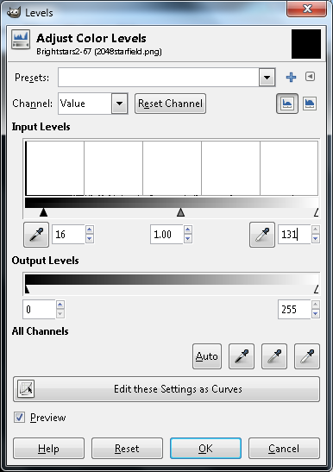

Move Brightstars2 to below Neb-Base-Color, but above Striations. Duplicate Brightstars2 by selecting “Layer/Duplicate”. Rename this layer Brightstars3.

Blur the stars a little by selecting “Filter/Blur/Gaussian Blur” and setting horizontal and verticle both to 3. See *fig 4-6*, and hit “OK”.

***fig 4-6***

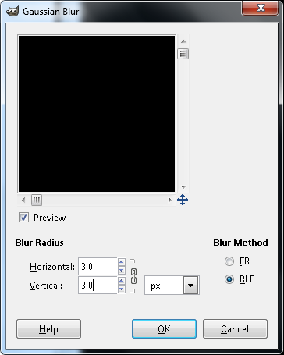

Now because the blurring reduces the brightness of the stars, let’s bring them back into sight by selecting “Colors/Auto/Stretch Contrast”.

With Brightstars3 selected, we will duplicate it by selecting “Layers/Duplicate Layer”. Rename this layer Birghtstars4.

Blur the stars a little by selecting “Filter/Blur/Gaussian Blur” and setting horizontal and verticle both to 7. See *fig 4-7*, and hit “OK”.

***fig 4-7***

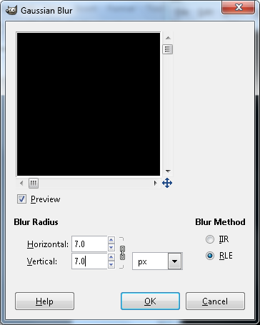

Repeat “Colors/Auto/Stretch Contrast”, like with the previous layer.

Set the blendmode of Brightstars3 and Brightstars4 to Screen.

You can now reduce the zoom back to 100%, and look around. You see blobs instead of pinpoints. If you move to view your upper left, you should be seeing *fig 4-9*.

***fig 4-9***

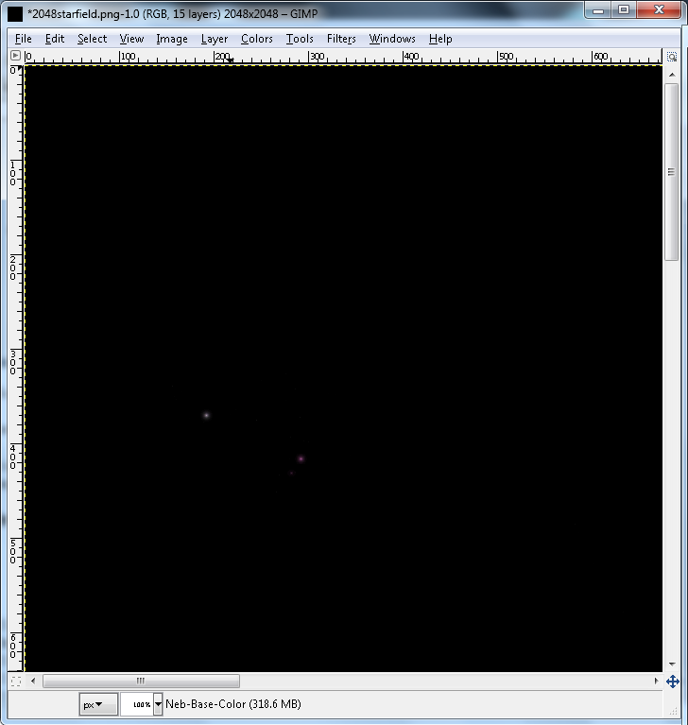

Lower the Opacity levels of Brightstars3 and Brightstars4 to 75%. For this operation, enable Neb-Base-Color and turn the Opacity up to 100%.

Copy what is visible by selecting “Edit/Copy Visible”, and then select Neb-Base-Color, and add a new layer above it by selecting “Edit/Paste as/New Layer”. Rename this layer Brightstars-final.

Now disable all of the layers, then go through each of them with the following checklist:

Enable Black, Blendmode Normal, Opacity 100%.

Enable Neb-Base, Blendmode Screen, Opacity 75%.

Enable Striations, Blendmode Multiply, Opacity 85%.

Enable Neb-Base-Color, Blendmode Color, Opacity 40%.

Enable Brightstars-final, Blendmode Screen, Opacity 100%.

Enable Neb-Top, Blendmode Screen, Opacity 50%.

Enable starfield, Blendmode Screen, Opacity 100%.

If this is too dark, you can enable Neb1, Neb2, and Neb3. Neb1 uses a blendmode of Overlay, Opacity at 100%. Neb2 uses a blendmode of Screen with an Opacity of 65%. Neb3 uses screen mode and Opacity at 50%. Enabling these layers is totally at the discretion of the artist, but it gives you options. Opacity and layers give a good deal of options. For the purposes of this tutorial, leave them disabled.

Alternatively, you can increase the Opacity values of Neb-Base and Neb-Top layers, or decrease opacity of Striations layer to adjust the overall brightness of the nebulae.

Across the top and down the left side you have a couple of scales. These are used for finding an item at a certain coordinate. The top scale represents the X coordinate, and the one on the left side represents your Y coordinate. Coordinates are always given in X,Y format. So, make sure that you are zoomed in at 100%, and then use your scroll bars to get to a view where you can place your cursor at 1620,930. See *fig 4-10*.

***fig 4-10***

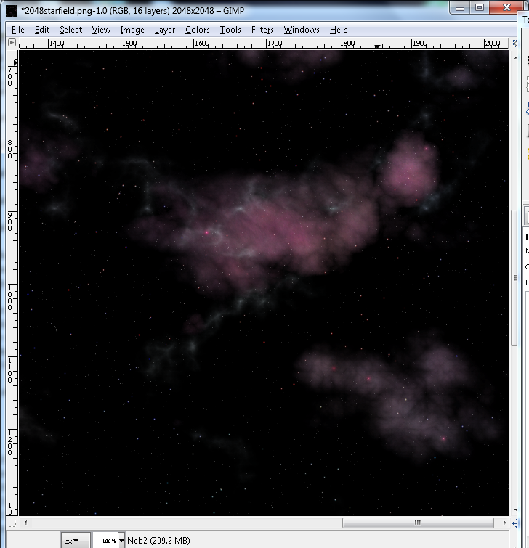

That bright pink star at your cursor is not blended very well, notice that the stars in the lower left nebula are not blended well either. When making these nebulae, look at each nebula at this stage to check the blending of the baby stars. We are going to fix this.

Disable the starfield.

Zoom in to 200% so that we can get a good view of the stars we want to tinker with.

With Brightstars-final selected, select “Colors/Hue-Saturation”. Set the saturation level to -51. See *fig 4-11*, and hit “OK”.

***fig 4-11***

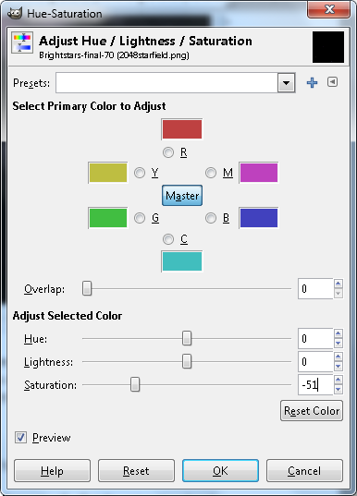

That is so much better. Set the Zoom back to 100%, and enable the starfield.

Save this as Nebula1.xcf file so that you can go back to this point if needs be.

With it saved, we can delete some unneeded layers, thus freeing up some memory. Deleting layers is easy, just select the layer to be deleted then select “Layers/Delete Layer”.

Delete Luminosity, Bightstars, Neb-Top-Color, Brightstars2, Brightstars3, Brightstars4.

Save this is Nebula1a.xcf.

“Most of this is also a matter of taste, and has to be applied on present conditions and what you think looks good, and it's also important to experiment with different things to find what might produce interesting and good looking results.” - Herra Tohtori

**Come to the Dark Side, we have cookies.**

We need to work on something that isn’t needed, but can add some wonderfully subtle depth. Shadows, and dark nebula layers. This is a simple process that we will repeat with separate settings.

**1st Layer of shadows**

Select the starfield layer, then create a new layer above it by selecting “Layer/New Layer”. Name this new layer DarkNeb-Alpha.

Let’s add our clouds. With DarkNeb-Alpha selected, select “Filter/Render/Clouds/Plasma”. Using Random Seed 2545379861, and “Turbulence” set to 7. Make this seamless by selecting “Filer/Map/Make Seamless”.

With DarkNeb-Alpha selected desaturate it by selecting “Colors/Desaturate”. Use the “Average” option. See *fig 5-*1 and hit “OK”.

***fig 5-1***

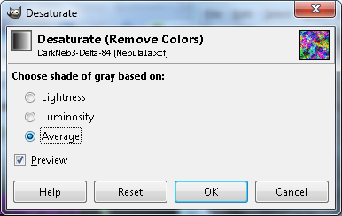

With that done, select “Colors/Threshold”, and set black for 160. See *fig 5-2* and hit “OK”.

***fig 5-2***

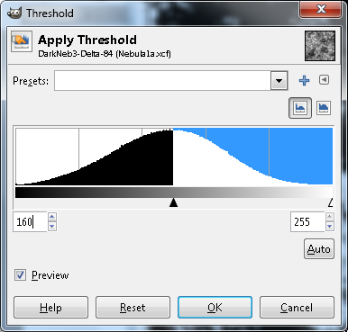

This should just look like black white splochy. Quite ugly actually.

Select Neb1. Then select “Layers/Duplicate Layer”. Drag the duplicate layer to just above DarkNeb-Alpha. Make sure that it is enabled, then set blendmode to “Multiply”. The white splotches should now be mostly gray. Still ugly.

Copy what is visible by selecting “Edit/Copy Visible”.

With Neb1copy selected, create a new, completely black layer by selecting “Layers/New Layer”. This is easiest to do by making sure your Foreground color is black, then selecting “Foreground color” in the New Layer dialogue.

Name this layer DarkNeb1. Give this layer a mask by selecting “Layers/Mask/add Layer Mask”. When the dialogue box appears, select the “Black(full transparency)” option. See *fig 5-3* and hit “ADD”.

***fig 5-3***

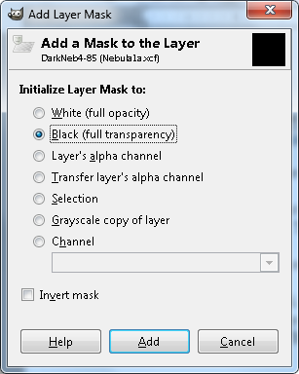

With the layer mask selected, paste what you copied a couple of steps ago by hitting CTRL+V, and then anchor it by hitting CTRL+H.

Disable Neb1copy and DarkNeb-Alpha. You should now see some dark splotches over your nebula. They don’t look very good, but we will fix that.

With the layer mask still selected, select “Filters/Blur/Gaussian Blur”. When the dialogue box appears, make sure that 2 is entered for X and Y. See *fig 5-4* and hit “OK”.

***fig 5-4***

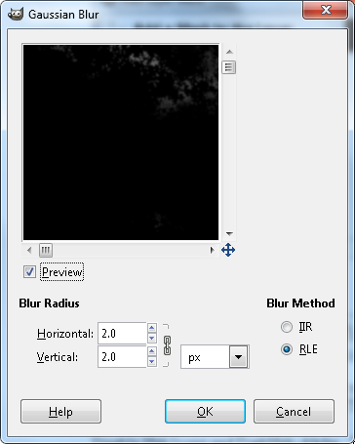

Select “Colors/Levels”. Working with input, set “Black” to 50 and “Gamma” to .35.

Set the Opacity of this layer at 100.

That’s it, all we will do now is repeat those steps.

**2nd Layer of shadows**

Select the DarkNeb-Alpha layer, then create a new layer above it by selecting “Layer/New Layer”. Name this new layer DarkNeb-Beta.

Let’s add our clouds. With DarkNeb-Beta selected, select “Filter/Render/Clouds/Plasma”. Using Random Seed 212298951, and “Turbulence” set to 7.

Make this seamless by selecting “Filter/Map/Make Seamless”.

With DarkNeb-Beta selected desaturate the it by selecting “Colors/Desaturate”. Use the “Average” option.

With that done, select “Colors/Threshold”, and set black for 160.

Disable DarkNeb1. Enable Neb1 copy.

Copy what is visible by selecting “Edit/Copy Visible”.

With DarkNeb1 selected, create a new layer by selecting “Layers/New Layer”. Name this layer DarkNeb2. Give this layer a mask by selecting “Layers/Mask/add Layer Mask”. When the dialogue box appears, select the “Black(full transparency)” option.

With the layer mask selected, paste what you copied a couple of steps ago by hitting CTRL+V, and then anchor it by hitting CTRL+H.

Disable Neb1copy and DarkNeb-Beta. You should now see some dark splotches over your nebula. They don’t look very good, but we will fix that.

With the layer mask still selected, select “Filters/Blur/Gaussian Blur”. When the dialogue box appears, make sure that 2 is entered for X and Y.

Select “Colors/Levels”. Working wiht input, set “Black” to 100 and “Gamma” to .75.

Set the Opacity of this layer at 100.

**3rd Layer of shadows**

Select the DarkNeb-Beta layer, then create a new layer above it by selecting “Layer/New Layer”. Name this new layer DarkNeb-Gamma.

Let’s add our clouds. With DarkNeb-Gamma selected, select “Filter/Render/Clouds/Plasma”. Using Random Seed 4174082222, and “Turbulence” set to 7.

Make this seamless by selecting “Filer/Map/Make Seamless”.

With DarkNeb-Gamma selected desaturate the it by selecting “Colors/Desaturate”. Use the “Average” option.

With that done, select “Colors/Threshold”, and set black for 160.

Disable DarkNeb2. Enable Neb1 copy.

Copy what is visible by selecting “Edit/Copy Visible”.

With DarkNeb2 selected, create a new layer by selecting “Layers/New Layer”. Name this layer DarkNeb3. Give this layer a mask by selecting “Layers/Mask/add Layer Mask”. When the dialogue box appears, select the “Black(full transparency)” option.

With the layer mask selected, paste what you copied a couple of steps ago by hitting CTRL+V, and then anchor it by hitting CTRL+H.

Disable Neb1copy and DarkNeb-Gamma. You should now see some dark splotches over your nebula. They don’t look very good, but we will fix that.

With the layer mask still selected, select “Filters/Blur/Gaussian Blur”. When the dialogue box appears, make sure that 2 is entered for X and Y.

Select “Colors/Levels”. Working wiht input, set “Black” to 110 and “Gamma” to .35.

Set the Opacity of this layer at 100.

**4th Layer of shadows**

Select the DarkNeb-Gamma layer, then create a new layer above it by selecting “Layer/New Layer”. Name this new layer DarkNeb-Delta.

Let’s add our clouds. With DarkNeb-Delta selected, select “Filter/Render/Clouds/Plasma”. Using Random Seed 2817700572, and “Turbulence” set to 7.

Make this seamless by selecting “Filer/Map/Make Seamless”.

With DarkNeb-Delta selected desaturate it by selecting “Colors/Desaturate”. Use the “Average” option.

With that done, select “Colors/Threshold”, and set black for 160.

Disable DarkNeb3. Enable Neb1 copy.

Copy what is visible by selecting “Edit/Copy Visible”.

With DarkNeb3 selected, create a new layer by selecting “Layers/New Layer”. Name this layer DarkNeb4. Give this layer a mask by selecting “Layers/Mask/add Layer Mask”. When the dialogue box appears, select the “Black(full transparency)” option.

With the layer mask selected, paste what you copied a couple of steps ago by hitting CTRL+V, and then anchor it by hitting CTRL+H.

Disable Neb1copy and DarkNeb-Delta. You should now see some dark splotches over your nebula. They don’t look very good, but we will fix that.

With the layer mask still selected, select “Filters/Blur/Gaussian Blur”. When the

dialogue box appears, make sure that 2 is entered for X and Y.

Select “Colors/Levels”. Working with input, set “Black” to 105 and “Gamma” to .35.

Set the Opacity of this layer at 100.

**5th Layer -Final Darkness**

Select the DarkNeb-Delta layer, then create a new layer above it by selecting “Layer/New Layer”. Name this new layer DarkNeb-Epsilon.

Let’s add our clouds. With DarkNeb-Epsilon selected, select “Filter/Render/Clouds/Plasma”. Using Random Seed 2208074172, and “Turbulence” set to 7.

Make this seamless by selecting “Filer/Map/Make Seamless”.

With DarkNeb-Epsilon selected desaturate the it by selecting “Colors/Desaturate”. Use the “Average” option.

With that done, select “Colors/Threshold”, and set black for 160.

Disable DarkNeb4. Enable Neb1 copy.

Copy what is visible by selecting “Edit/Copy Visible”.

With DarkNeb4 selected, create a new layer by selecting “Layers/New Layer”. Name this layer DarkNeb5. Give this layer a mask by selecting “Layers/Mask/add Layer Mask”. When the dialogue box appears, select the “Black(full transparency)” option.

With the layer mask selected, paste what you copied a couple of steps ago by hitting CTRL+V, and then anchor it by hitting CTRL+H.

Disable Neb1copy and DarkNeb-Epsilon. You should now see some dark splotches over your nebula. They don’t look very good, but we will fix that.

With the layer mask still selected, select “Filters/Blur/Gaussian Blur”. When the dialogue box appears, make sure that 2 is entered for X and Y.

Select “Colors/Brightness and Contrast”. Set “Contrast” to 30.

Set the Opacity of this layer at 100.

Enable DarkNeb1, DarkNeb2, DarkNeb3, and DarkNeb4.

Delete DarkNeb-Alpha, DarkNeb-Beta, DarkNeb-Gamma, DarkNeb-Delta, and DarkNeb-Epsilon.

Also note that if the dark nebula layer obscures the nebulas too much for your taste, you can always go down on the layer window, find the nebula-base layer and amp up that opacity to increase the nebula brightness.

For what it's worth, you might get good looking results with just a single dark nebula layer, or you might not want them at all. Or you might want to generate differing dark nebula patterns with different layers, and thus change the appearance of the otherwise same nebulae.

Right now you should have an xcf file set up on these lines. Refer to the link to view an xcf file that HT created....not the one from this tutorial.

<http://www.mediafire.com/?7g7dbt4espzp78q>

**And one to bind them**

At this stage we must diverge. Up until this point, the steps have been the same no matter what your plans were. This is where things will change.

If you have been through the tutorial and are now doing your own nebulae that will be standalone, ie, not lashed together. In this mindset each nebula that we have created will stand by itself as a complete nebula. Go to the blue section.

If you are lashing them together, as in finishing this tutorial, go to the red section.

***All Alone***

We can’t simply copy visible and paste it as a new image with higher resolutions(4096^2 or higher) because this will flatten the image and we will lose the depth created by our final dark layer. We need to be in higher resolutions for standalone nebulae because in lower resolutions the nebulae created by this tutorial are far too small to stand alone.

Step one is to disable your starfield.

In your toolbox select the “Lasso” tool. See *fig 6-1*.

***fig 6-1***

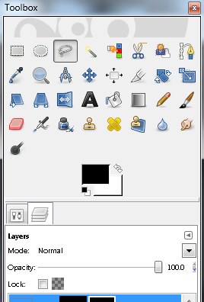

Remember at the beginning of the tutorial where it was emphasized that we use 2048^2 for this? Well now we use coordinates, which is the reason for that.

Across the top, you will see a scale, this gives you the horizontal position of the curser, referred to as “X“. Down the left hand side you see another scale, this gives you the verticle position of your curser, referred to as “Y”. Coordinates are given in “X,Y” format. Pretty self explanatory. Find the Nebula at 1700,900. Do not click on it.

Go a bit away from the nebula into the black, hold the left mouse button down and draw a shape completely enveloping the nebula.

You should have something like *fig 6-2*. If your line is green, and not dotted white, then simply double click, it should bring up the selection.

***fig 6-2***

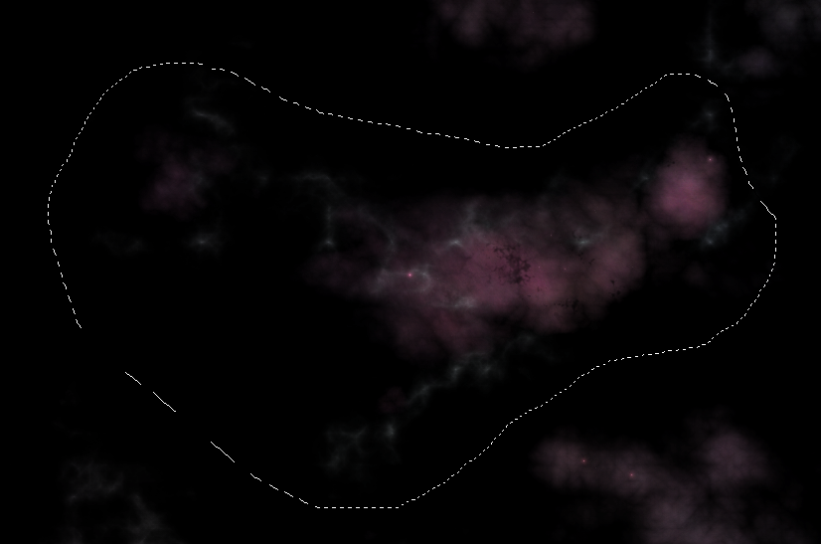

Copy the selection by selecting “Edit/Copy Visible”.

Paste this selection as a new image by selecting “Edit/Paste/New Image”. Name this layer Nebula.

We need to add an Alpha channel to this, do this by selecting “Layer/Transparency/Color to Alpha”. When the Color to Alpha dialogue box comes up, click the long white button next to the word “From:”.

This brings up the Color to Alpha Color Picker dialogue box. For HTML Notation just enter “000000”. See *fig 6-3* and hit “OK”.

***fig 6-3***

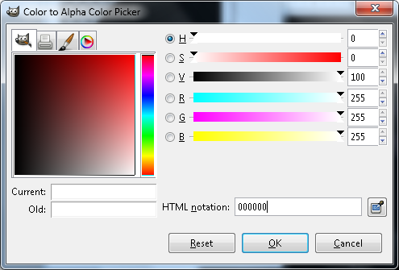

Once back at the Color to Alpha dialogue box, the long white button should now be black. Hit “OK”.

This layer should now be very very dim. Anything on this layer that is black is now transparent. You can test this by creating a new black layer. Select “Layer/New Layer”. Name the layer “Black” and make sure that foreground color is selected.

Drag the black layer to the bottom of the list. You should now see your nebula just fine. Here is the problem. The black layers in that image are now transparent, this will not do.

So what we do is simple. Bring up your Nebula.xcf, and disable everything except DarkNeb1 through DarkNeb5. You should be seeing the checkerboard with only a few dark splotches on it.

Copy the selection by selecting “Edit/Copy Visible”.

Now switch over to the new image, the one of just one nebula. Paste your selection as a new layer by selecting “Edit/Paste as/NewLayer”. Name this new Layer “Dark”.

Move Dark to beneath Nebula, but above Black.

Now add a starfield as a Layer. Reduce its opacity until you are happy. But note, no stars are shining through the dark areas. Perfect.

Finally, disable the starfield.

Save this as a PNG or any other format that supports an Alpha channel. It won’t look like much, but it will be perfect when placed over a starfield.

That’s it for creating standalone nebulae.

**That is one big pile of crap.**

If we are working in a lower resolution (below 4096^2) it is time for lashing nebula together. Let’s go ahead and use the crap analogy for this. Everyone knows that one big pile of crap consists of smaller pieces of crap bound together. These smaller pieces of crap are usually discovered stuck to the bottom of your shoe.

Each of the nebulae that we’ve just created is like a small piece of crap. We need to bind them together in order to have a nebula big enough to use. The smaller the resolution, the smaller the nebulae, the more you will have to bind them to get something large enough to be usable. Because these are so small, the detail level is nowhere as good as it is at the higher resolutions, so depth loss here isn’t noticeable enough to warrant a more complex set of operations.

First, let’s make sure that the following layers are enabled:

DarkNeb5

DarkNeb4

DarkNeb3

DarkNeb2

DarkNeb1

Neb-Top

Neb3

Brightstars-Final

Neb-Base-Color

Striations

Neb-Base

Black

Notice that the starfield should not be enabled.

Select “Edit/Copy Visible”, and then paste as a new image by selecting “Edit/Paste as/New Image”. We will call this Image NebAll.

Now go back to the Nebula.xcf, and disable the 5 DarkNeb layers.

Select “Edit/Copy Visible”, and then paste as a new image by selecting “Edit/Paste as/New Image”. We will call this Image NebLight.

Switch back to Nebula.xcf and disable eveything except for Black.

Select “Edit/Copy Visible”, and then paste as a new image by selecting “Edit/Paste as/New Image”. We will call this Image Base.

Switch back to Nebula.xcf and enable the starfield.

Select “Edit/Copy Visible”, then switch back to Base, and select “Edit/Paste as/New Layer”. Name the new layer Starfield.

The basic idea now is to lasso a nebula and copy it into the Base image. Of course we can’t let it be that simple. So you should have 4 things open. Nebula.xcf, Base, NebAll, and NebLight. You can close Nebula.xcf now.

In your toolbox select the “Lasso” tool. See *fig 7-1*.

***fig 7-1***



Remember at the beginning of the tutorial where it was emphasized that we use 2048^2 for this? Well now we use coordinates, which is the reason for that.

Across the top, you will see a scale, this gives you the horizontal position of the curser, referred to as “X“. Down the left hand side you see another scale, this gives you the verticle position of your curser, referred to as “Y”. Coordinates are given in “X,Y” format. Pretty self explanatory. Using the NebLight image, find the Nebula at 100,1600. Do not click on it.

Go a bit away from the nebula into the black, hold the left mouse button down and draw a shape completely enveloping the nebula.

You should have something like *fig 7-2*. If your line is green, and not dotted white, then simply double click, it should bring up the selection.

***fig 7-2***

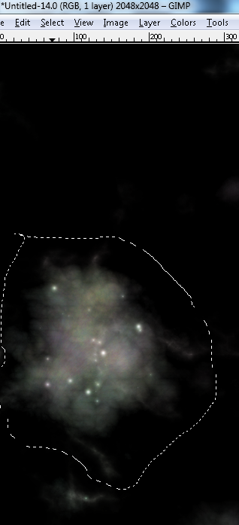

Copy the selection by selecting “Edit/Copy Visible”.

Switch your image to Base.

Create a new layer by selecting “Layer/New Layer”. Name this layer Neb1.

Paste the selection into the layer by hitting CTRL+V, and then anchor it by hitting CTRL+H. Name this layer Nebula. Set Blend Mode to screen.

Keep doing that with different nebulae from both the NebAll and NebLight images.

Play with opacity, layer movement, and rotating the layer to achieve some interesting results. Add as few or as many layers as you want.

Play with this for a bit to get the hang of what you are doing, then imagine what you can create if you 2 or 3 different nebula sheets to choose your pieces from.

**Some useful experiments to do with dark nebs:**

You can make dark nebulae similar to the globs we did by using Solid Noise, with turbulence on or off, instead of Plasma. Be creative to generate different styles of dark stuff. Dark stuff can add shadows, thereby creating depth, or it can be left as dense dark clouds within the nebula. Use of “Levels” will show you the difference.

Create a solid noise layer, then apply Iwarp to create whisps of dark dust.

You can do a webbed nebula by generating solid noise in turbulent mode with detail set 16/16. copy it, then scale it to 50%, and lay it over each of the quadrants. Then maybe even redo it.

*Above all, be creative and have some fun with this stuff.*

If you come up with any other experiments, let me know, and we can include them here in a revised edition.

And that is how to make nebulae in a 50 page tutorial.